**Delivery Hero: An Online Food Delivery Service**

**Task 1**

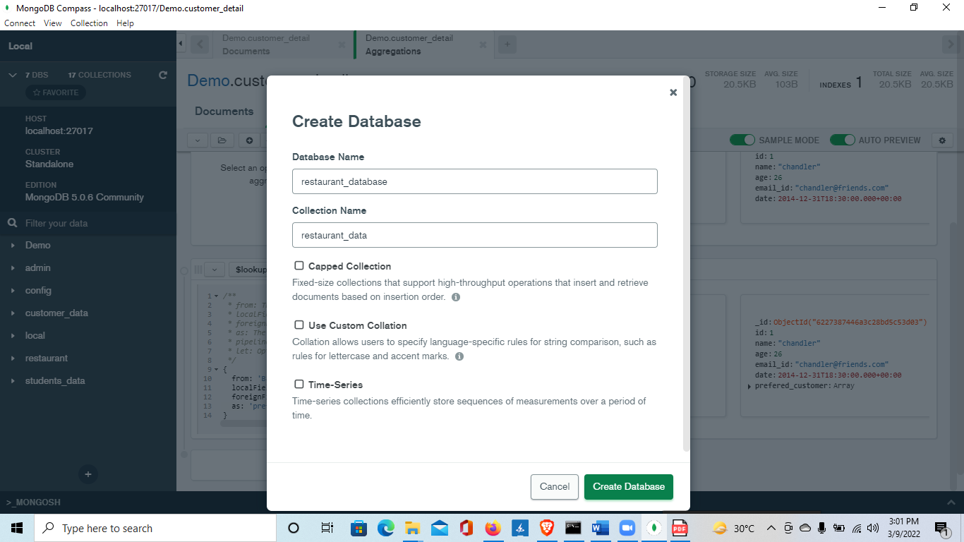

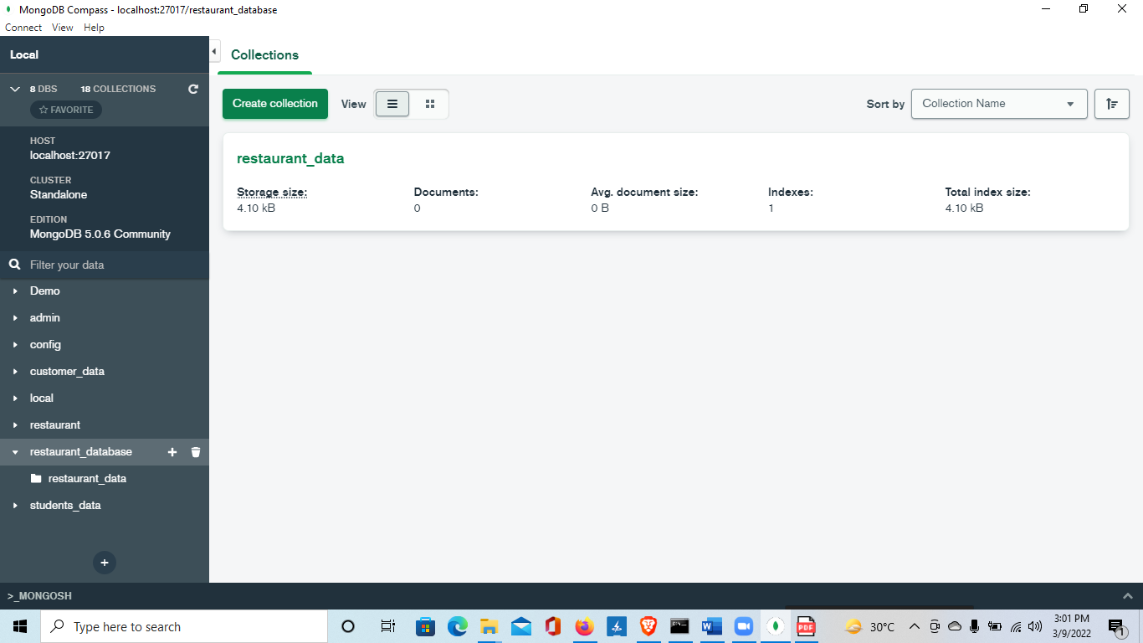

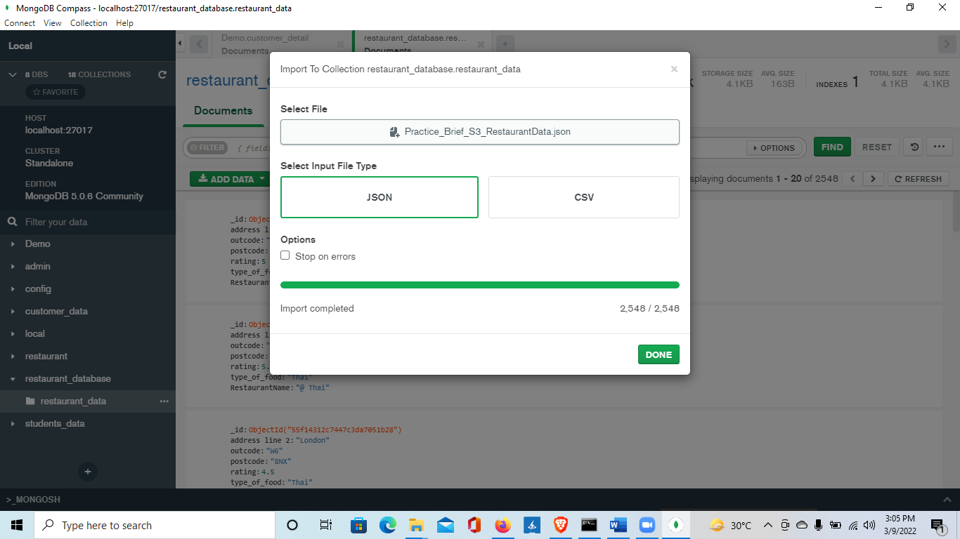

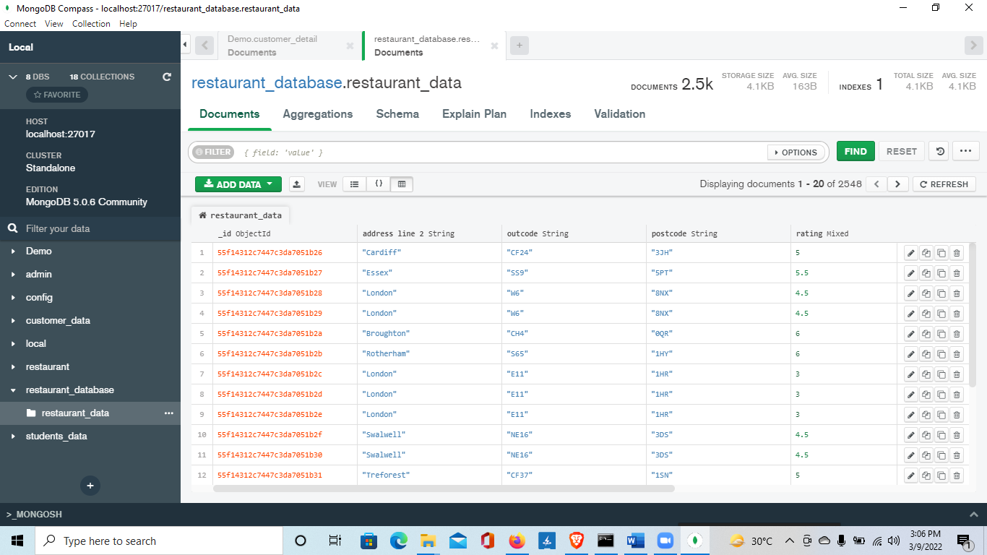

**Task 2**

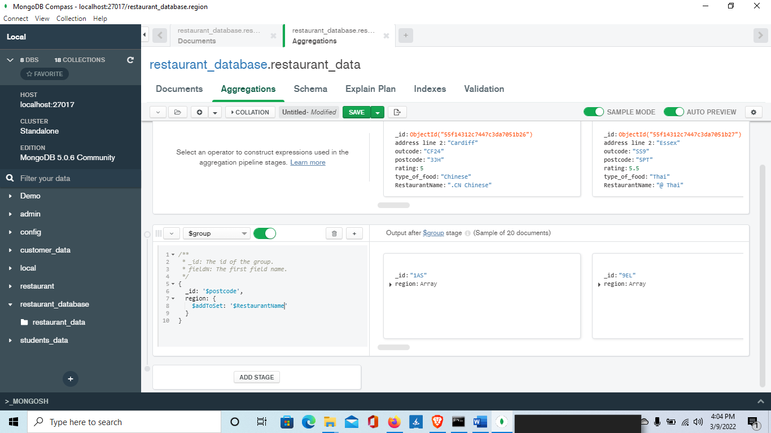

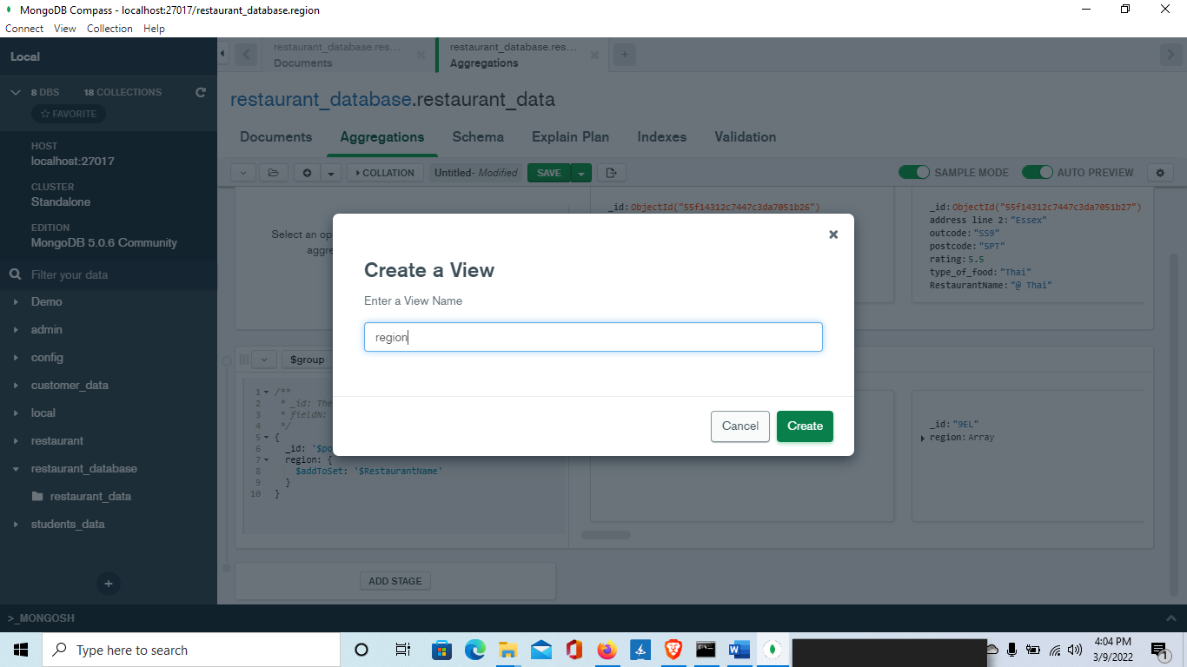

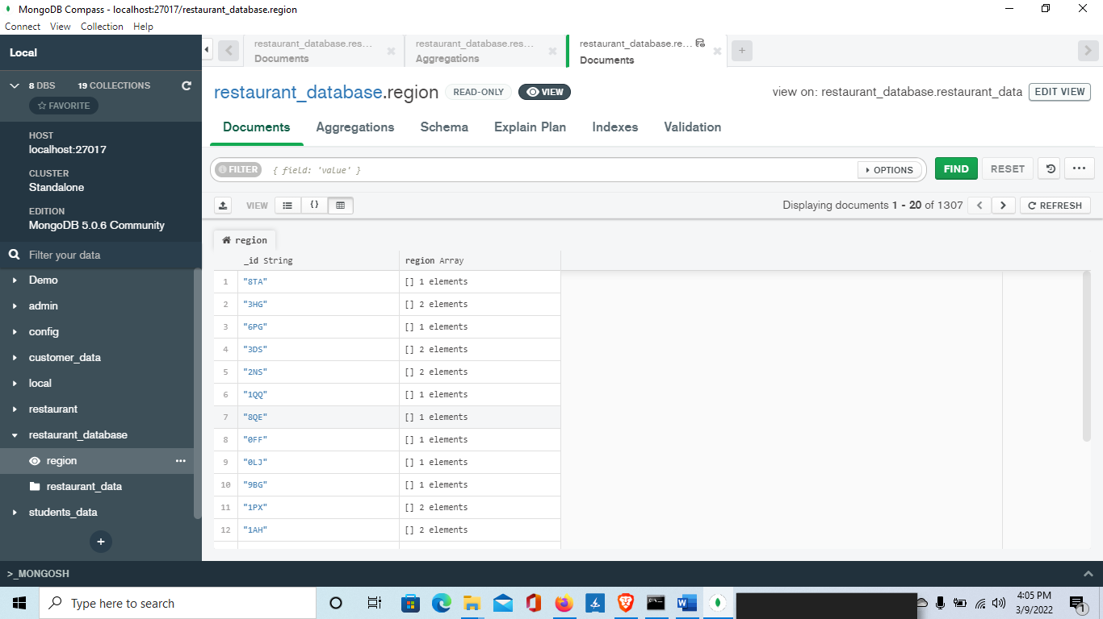

**AND**

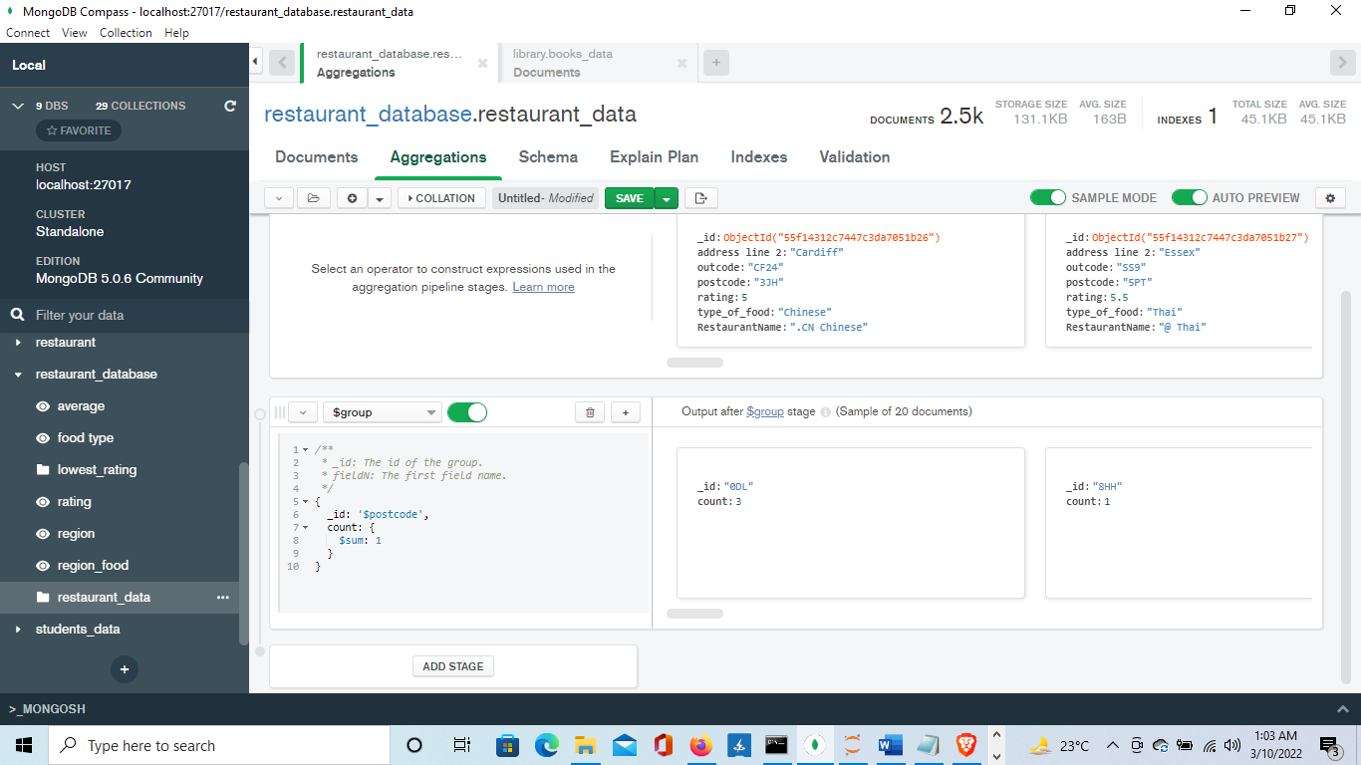

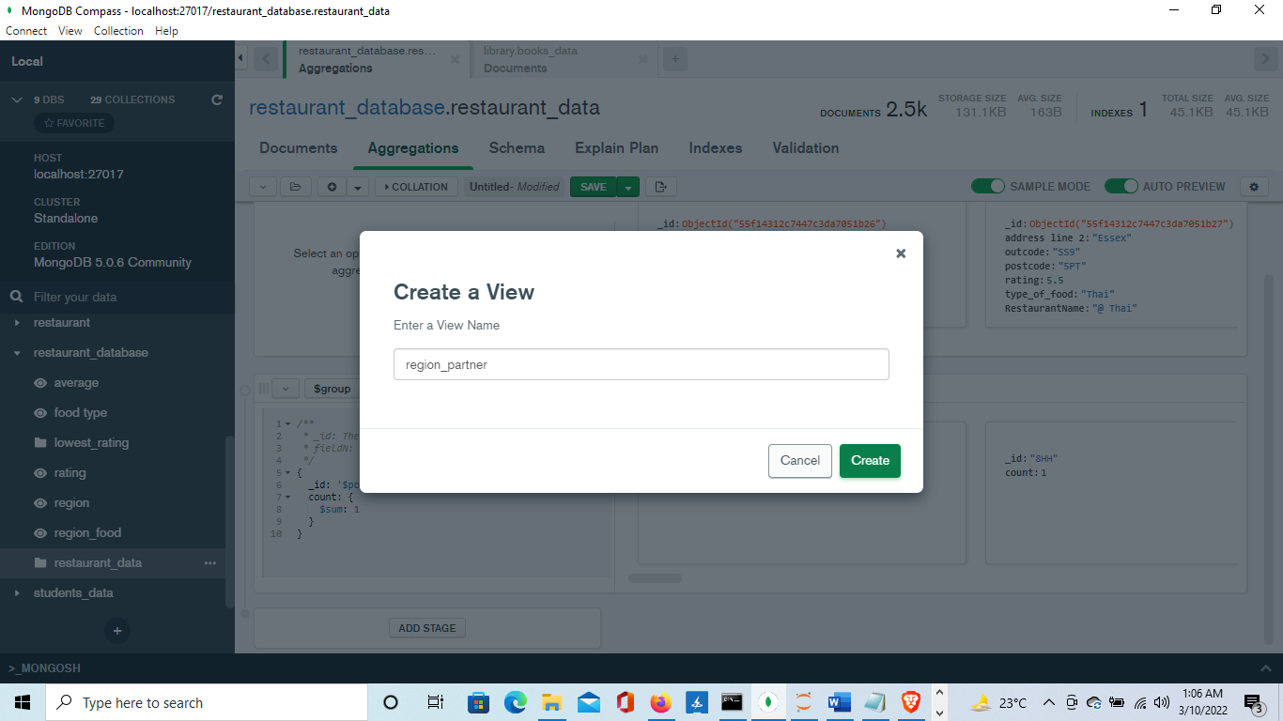

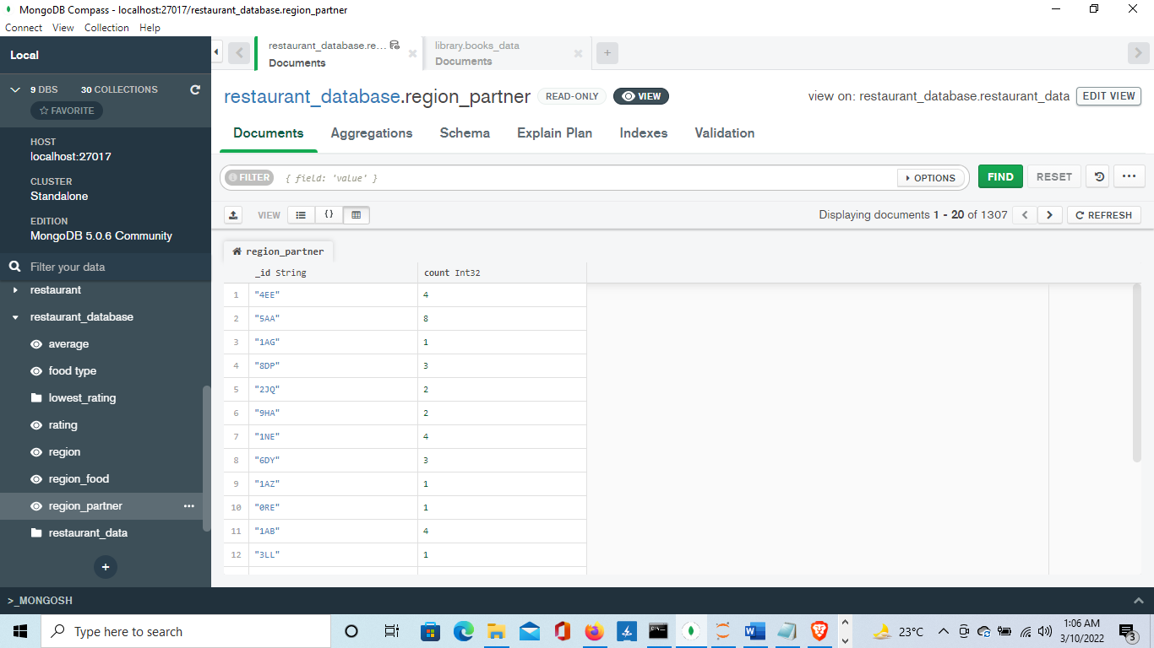

**Task 4**

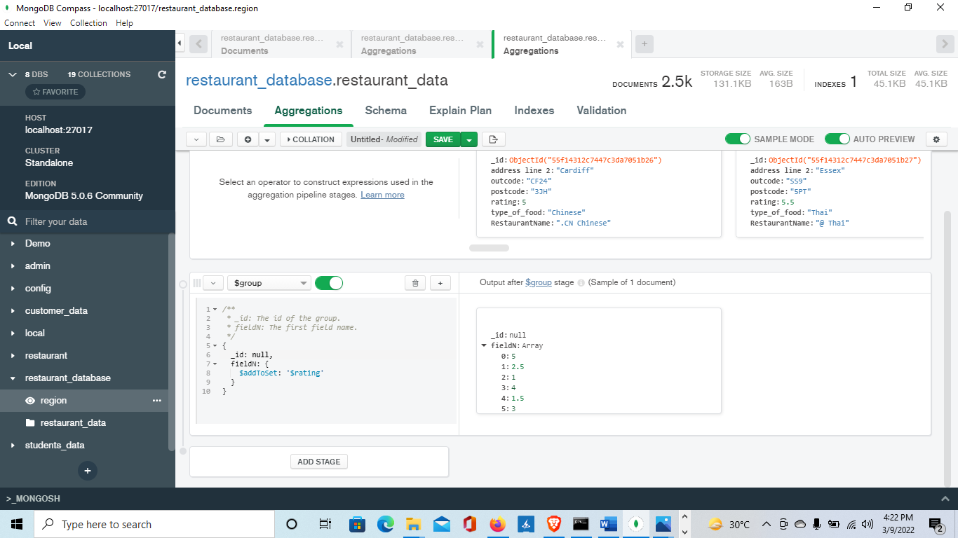

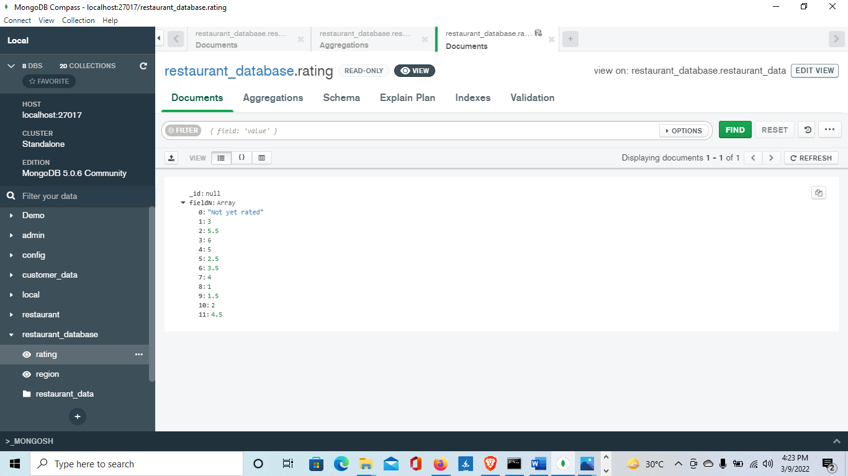

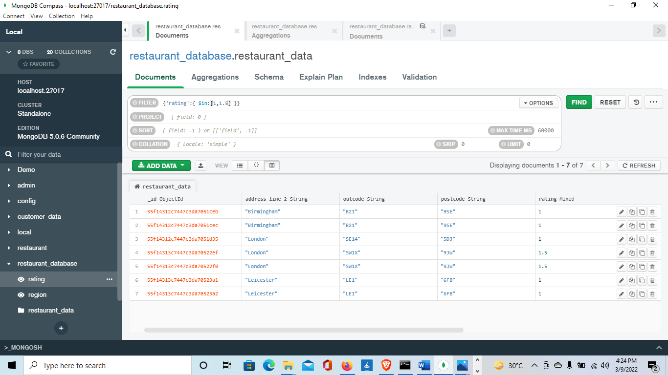

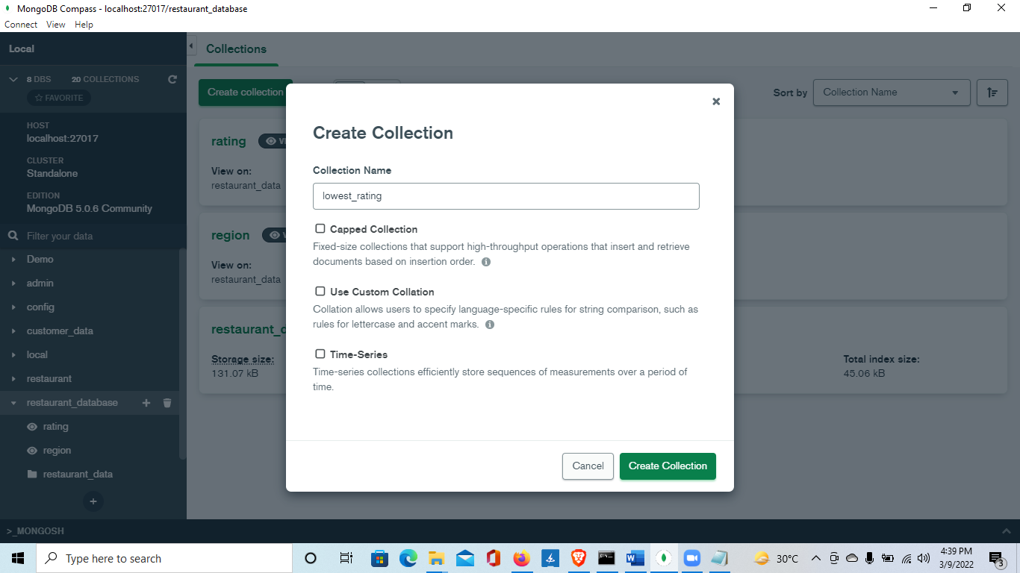

[{"_id":{"$oid":"55f14312c7447c3da7051ceb"},"address line 2":"Birmingham","outcode":"B21","postcode":"9SE","rating":1,"type_of_food":"Chicken","RestaurantName":"Al Dixi Fried Chicken & Grill House"},

{"_id":{"$oid":"55f14312c7447c3da7051cec"},"address line 2":"Birmingham","outcode":"B21","postcode":"9SE","rating":1,"type_of_food":"Chicken","RestaurantName":"Al Dixi Fried Chicken & Grill House"},

{"_id":{"$oid":"55f14312c7447c3da7051d35"},"address line 2":"London","outcode":"SE14","postcode":"5DJ","rating":1,"type_of_food":"African","RestaurantName":"Alaowerri Restaurant"},

{"_id":{"$oid":"55f14313c7447c3da70522ef"},"address line 2":"London","outcode":"SW1X","postcode":"9JW","rating":1.5,"type_of_food":"Lebanese","RestaurantName":"Beiteddine"},

{"_id":{"$oid":"55f14313c7447c3da70522f0"},"address line 2":"London","outcode":"SW1X","postcode":"9JW","rating":1.5,"type_of_food":"Lebanese","RestaurantName":"Beiteddine"},

{"_id":{"$oid":"55f14313c7447c3da70523a1"},"address line 2":"Leicester","outcode":"LE1","postcode":"6FB","rating":1,"type_of_food":"Chicken","RestaurantName":"Benny's"},

{"_id":{"$oid":"55f14313c7447c3da70523a2"},"address line 2":"Leicester","outcode":"LE1","postcode":"6FB","rating":1,"type_of_food":"Chicken","RestaurantName":"Benny's"}]

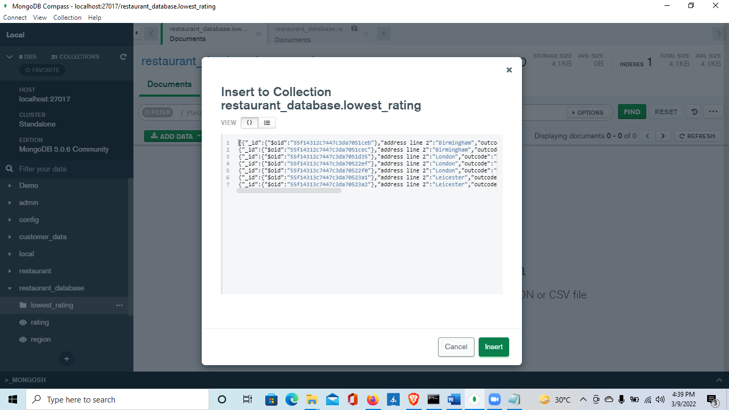

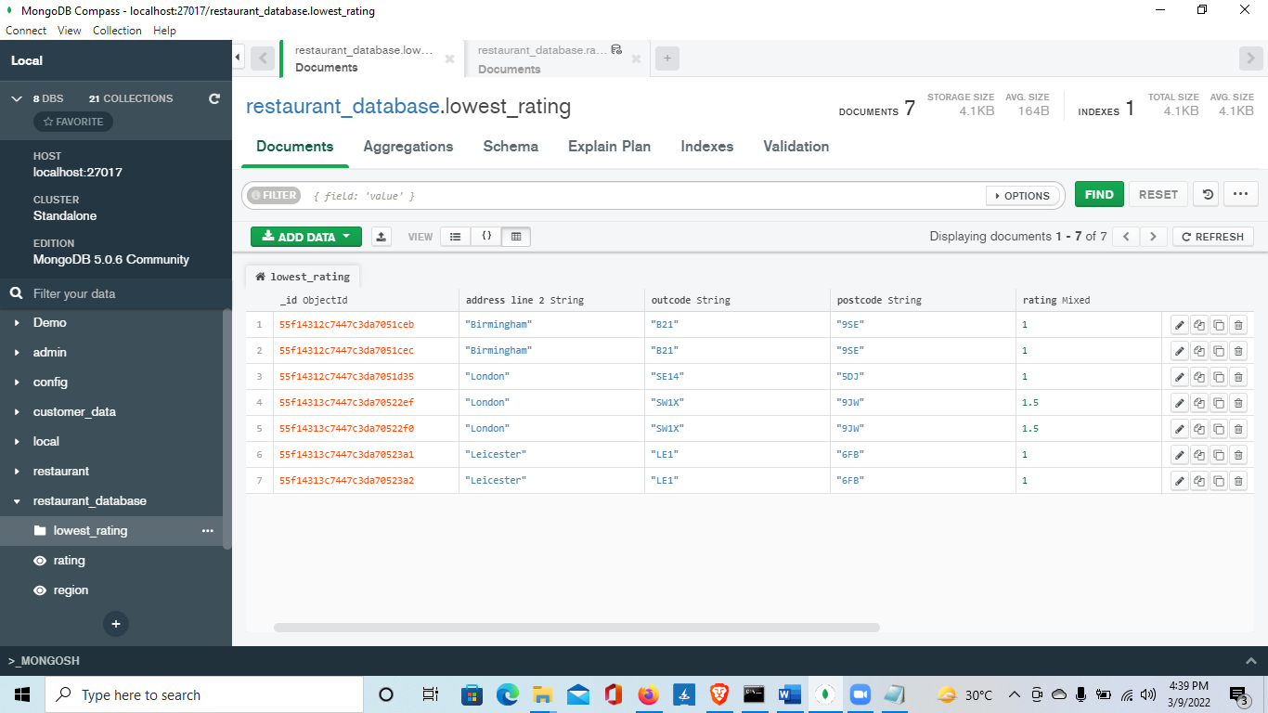

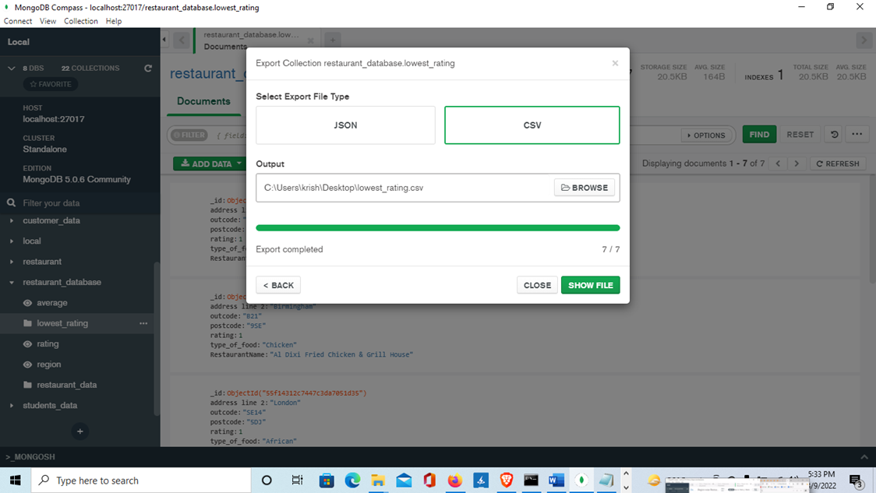

**Task 5**

{rating:{$gt:4}}

{rating:1,RestaurantName:1,type_of_food:1}

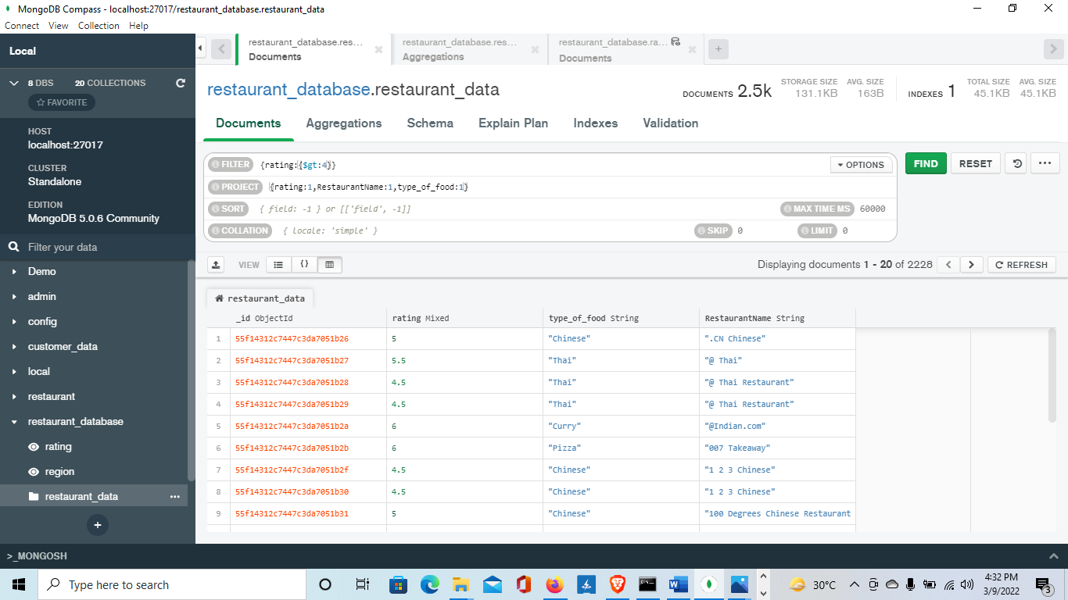

**Task 6**

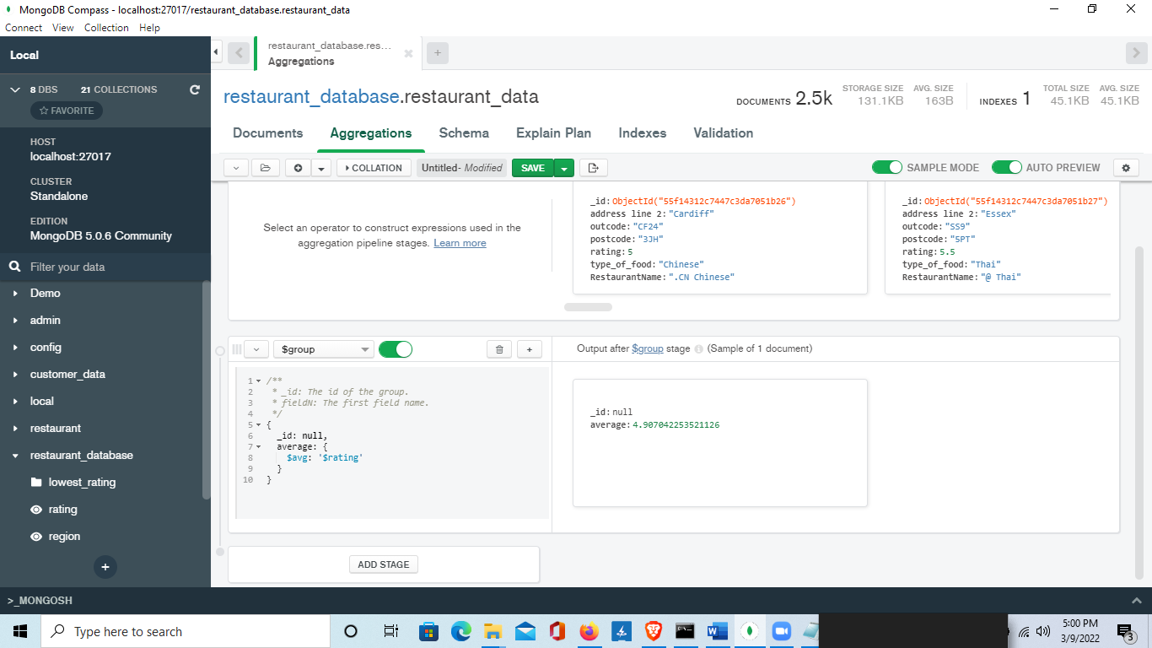

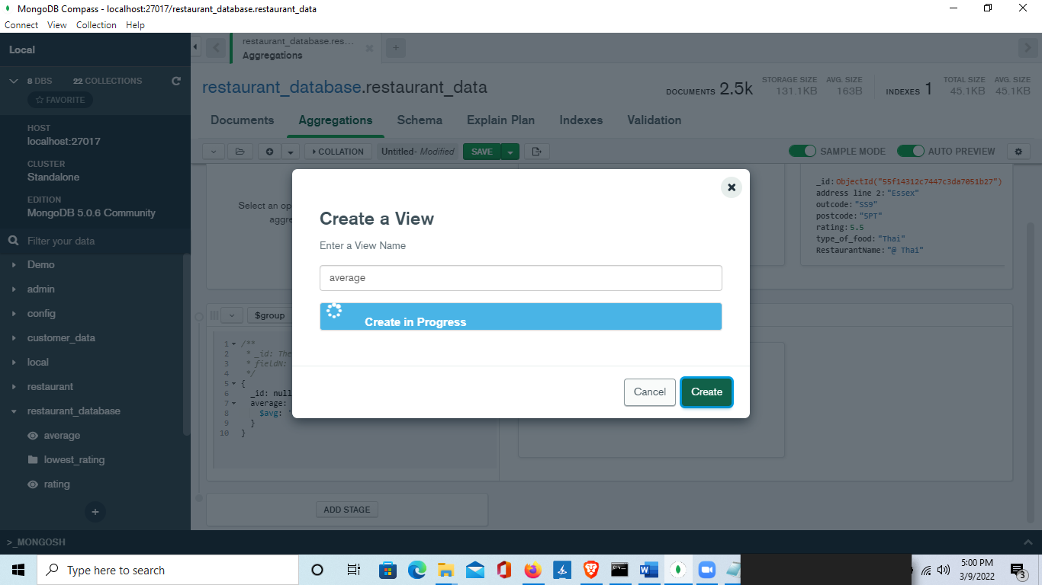

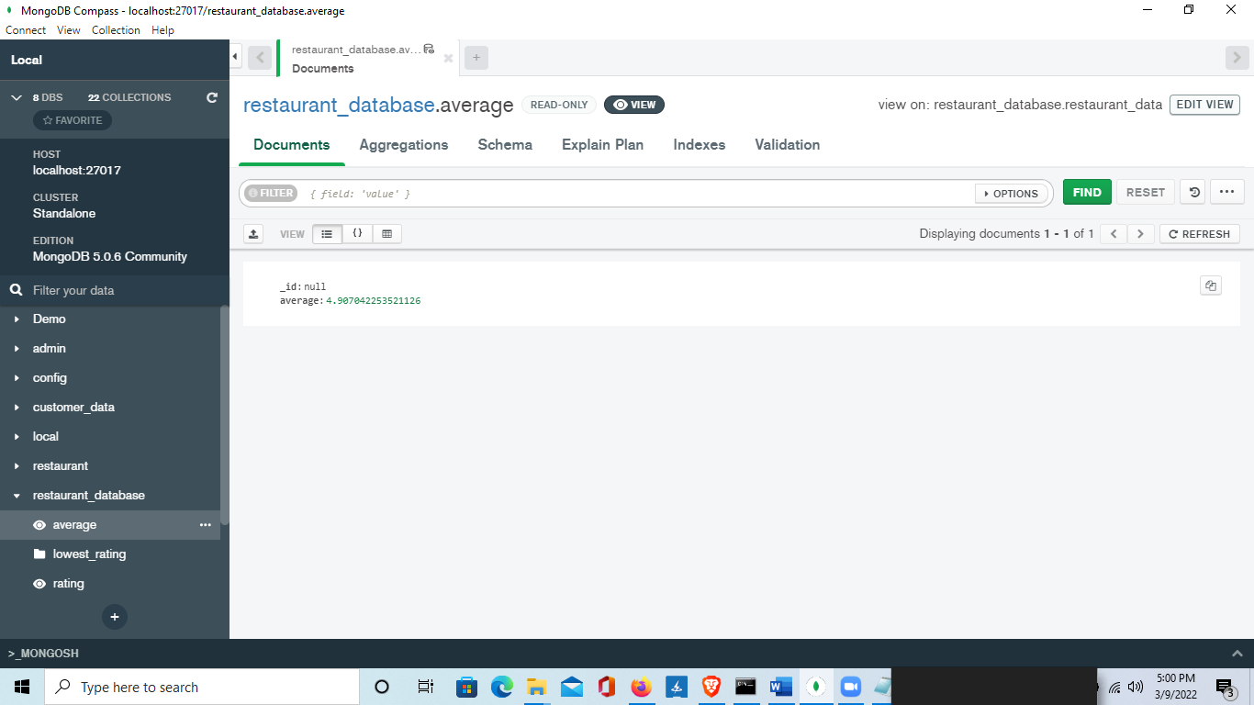

**Task 7**

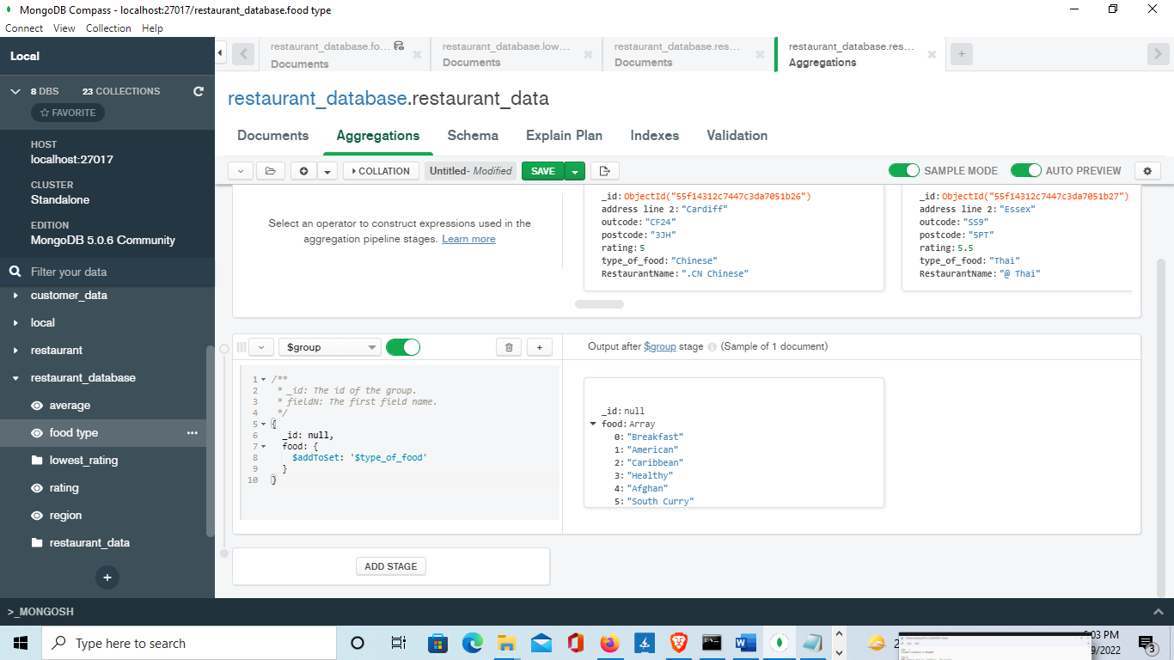

{type_of_food: { $exists: true, $in: [ "American","Caribbean","Afghan","Vietnamese","Mexican","Ethiopian","Bangladeshi","Sri-lankan","Azerbaijan","Korean","Lebanese","Portuguese","Polish","Chinese","Mediterranean","Nigerian","Greek","Moroccan","Japanese","Spanish","Arabic","African","Persian","Punjabi","Turkish","Russian","Pakistani","Thai"] } }

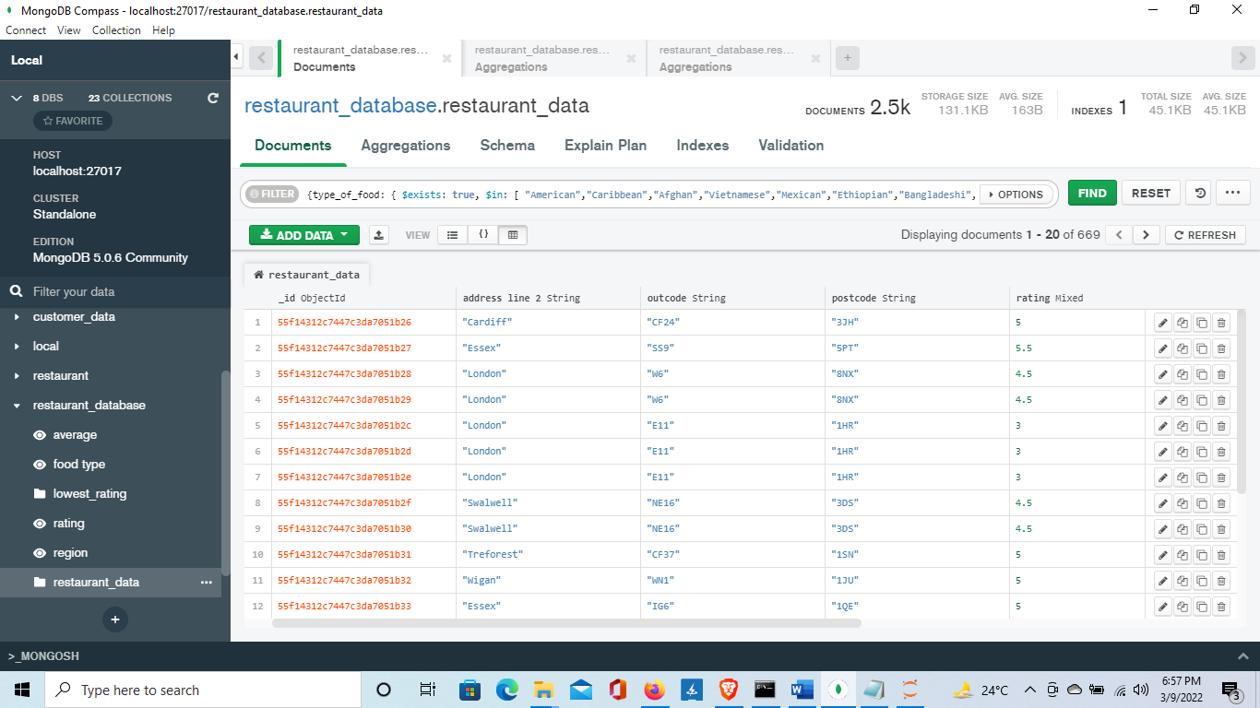

**Library**

**Task 1**

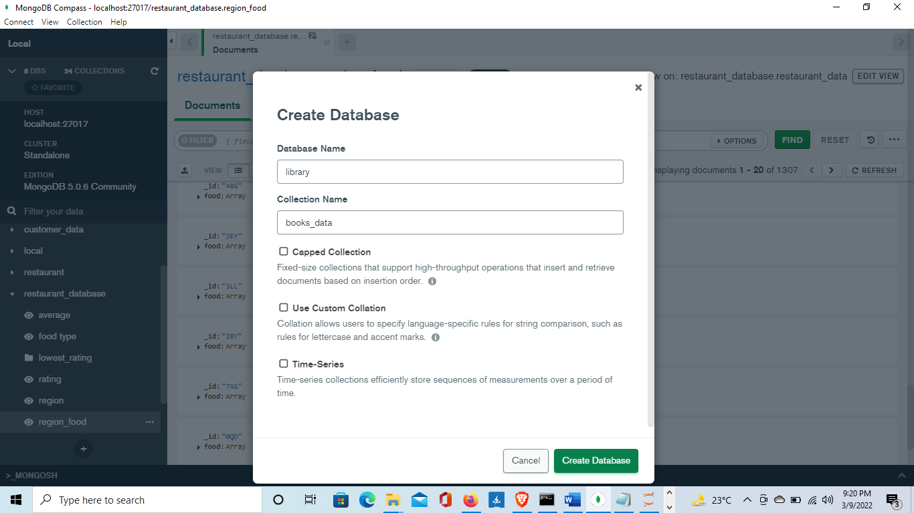

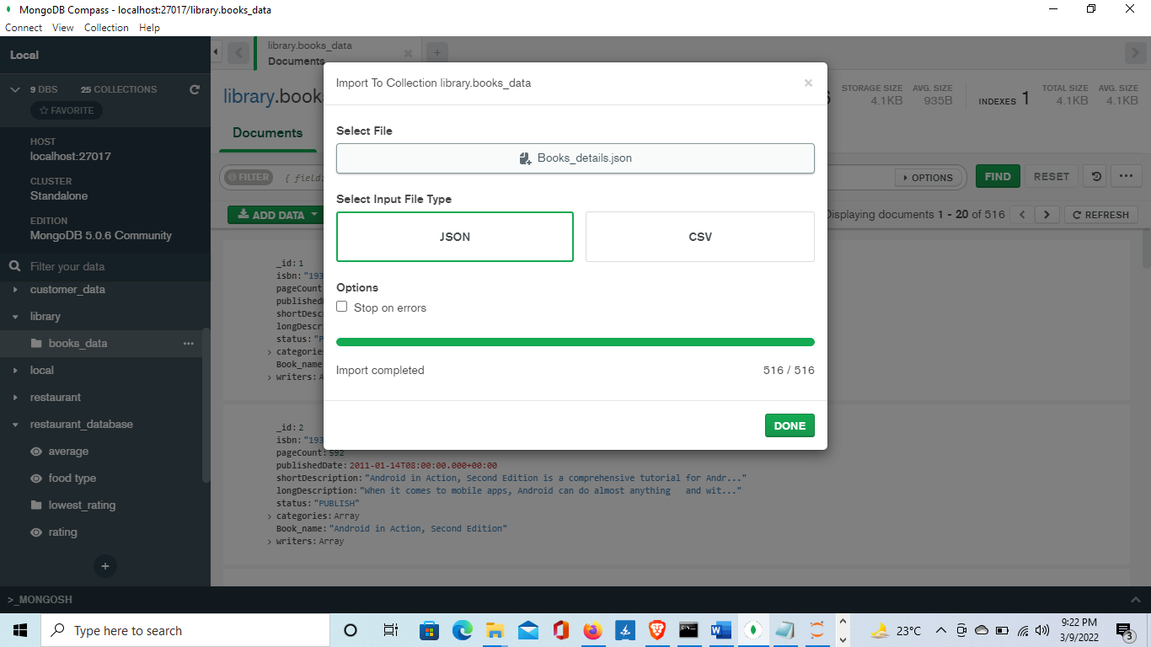

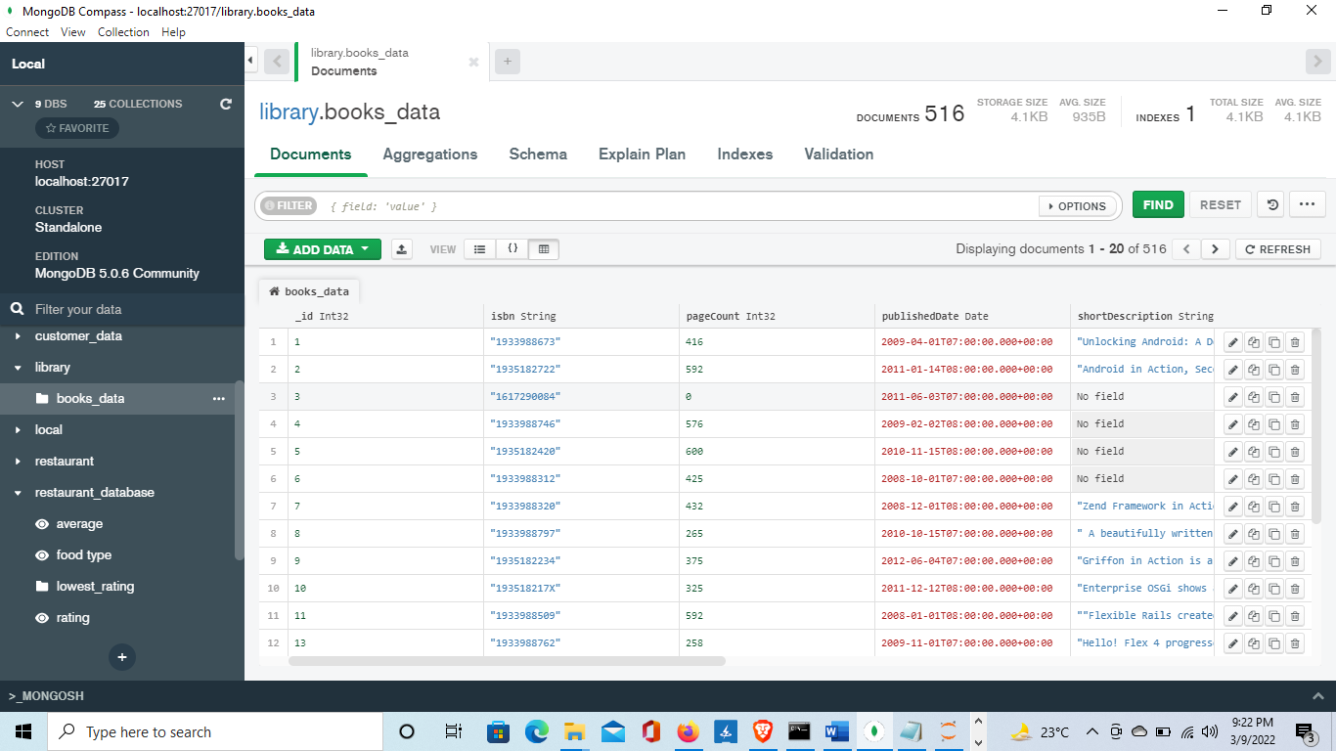

**Task 2**

{_id:1,Book_name:1,isbn:1,writers:1}

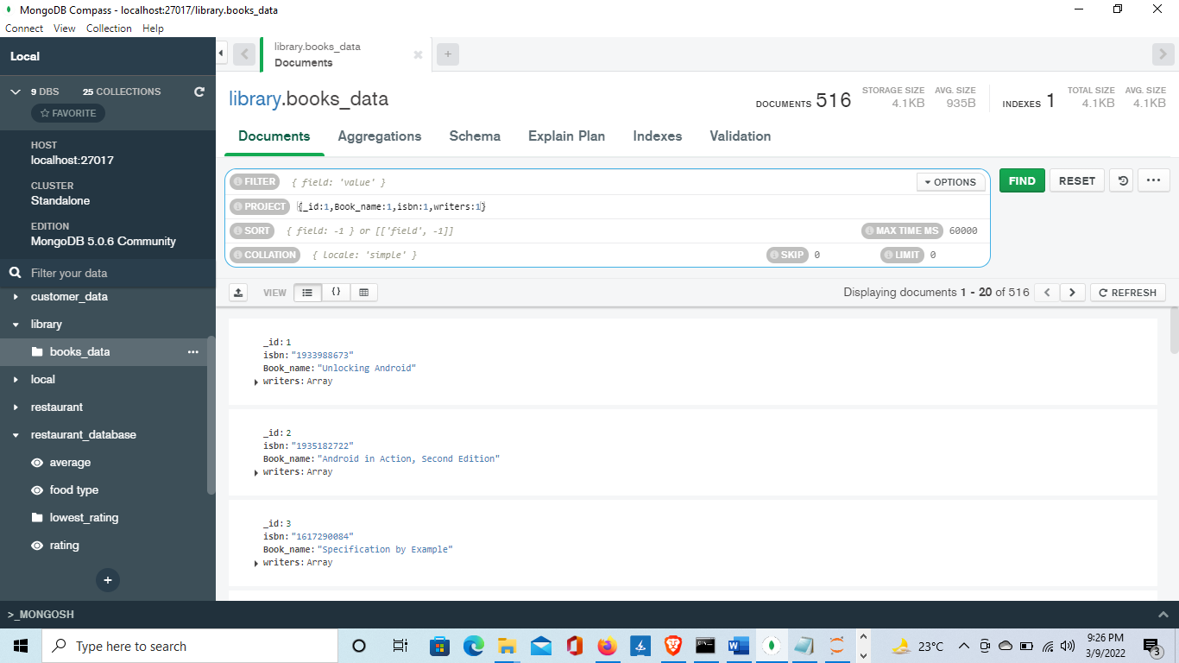

**Task 3**

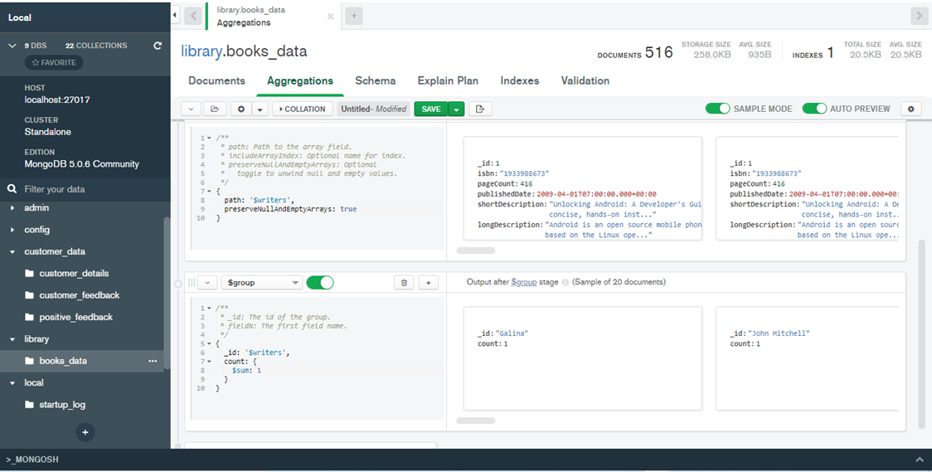

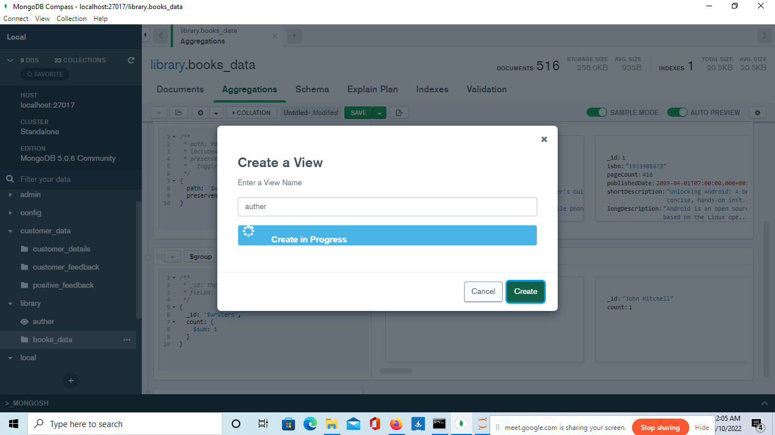

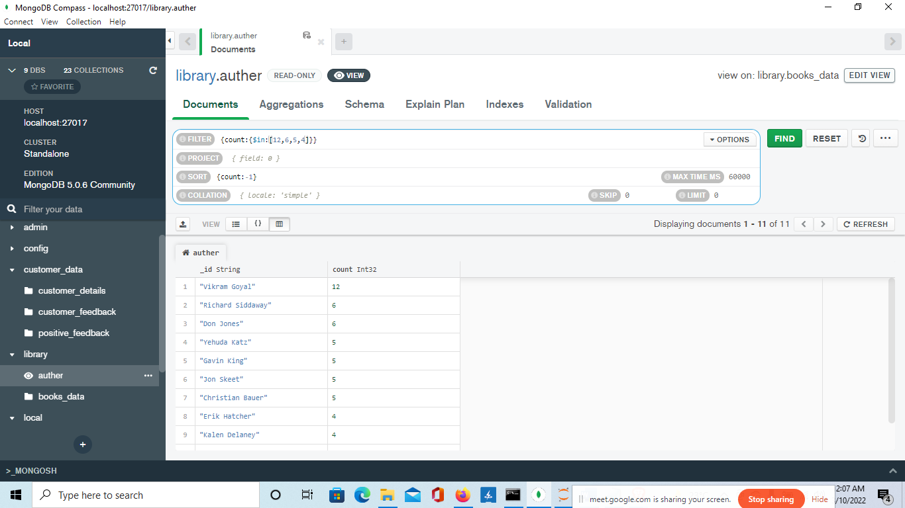

**Task 4**

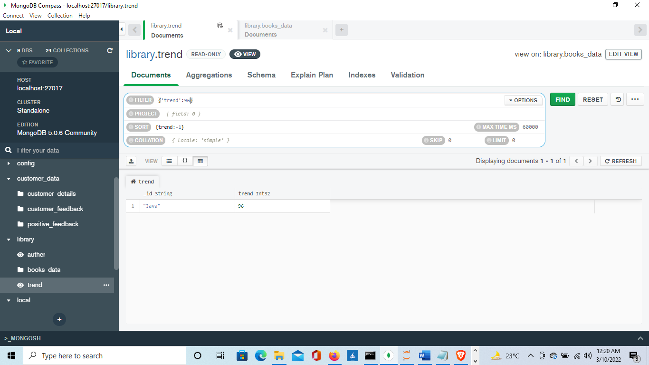

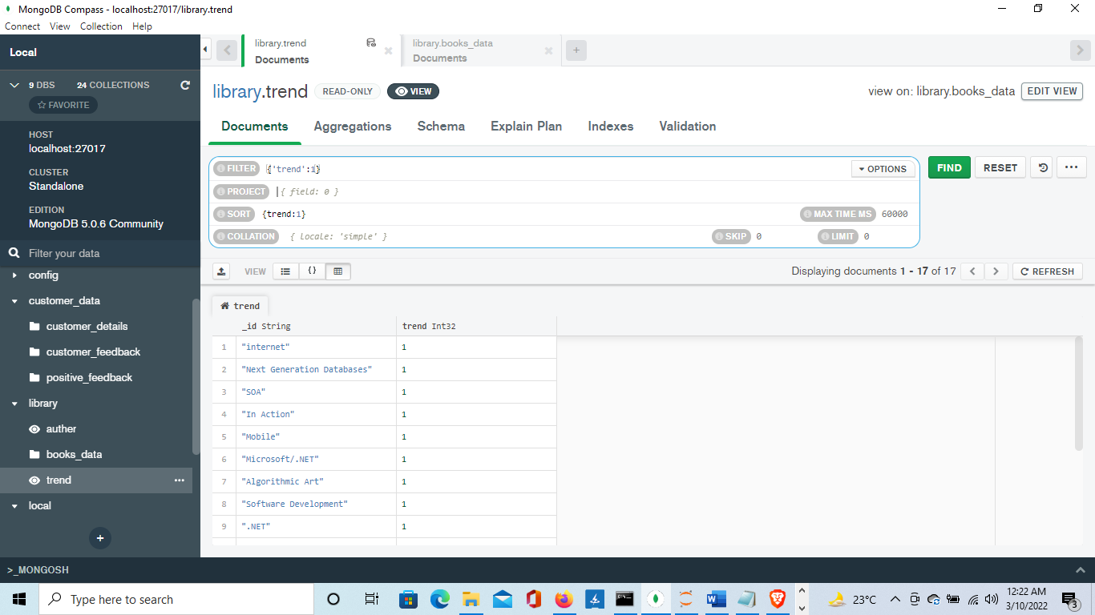

**Task 5**

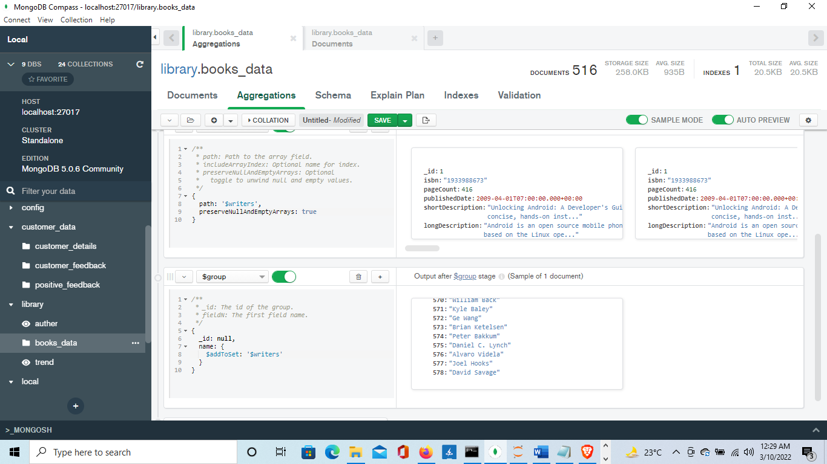

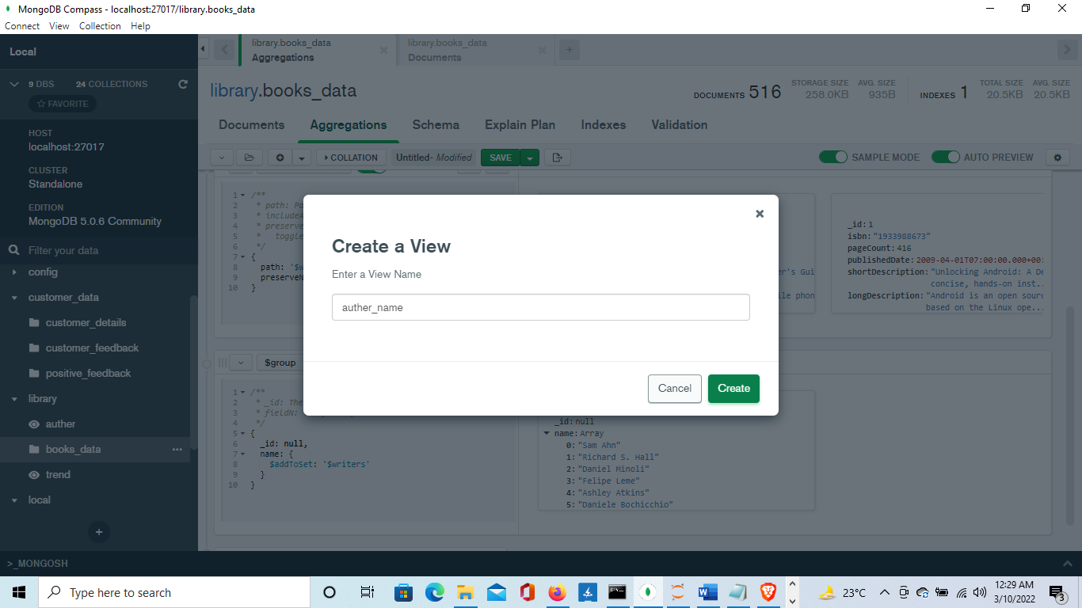

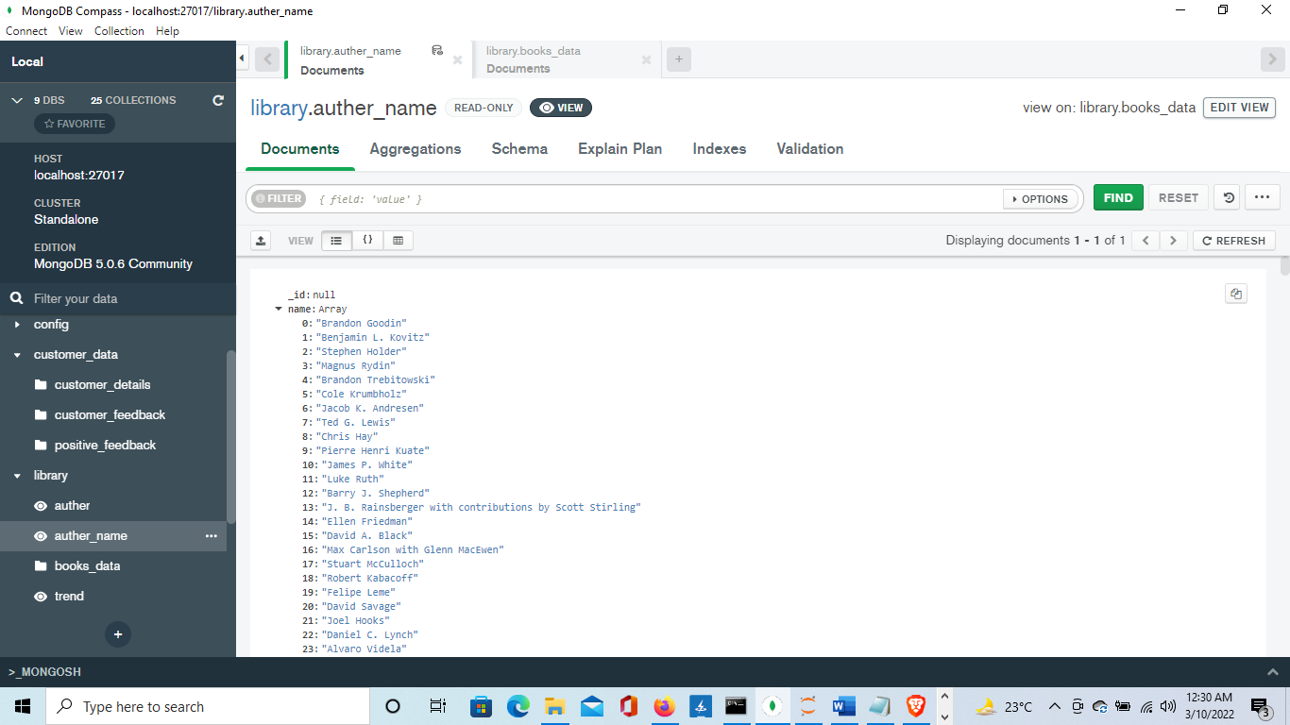

**Task 6**

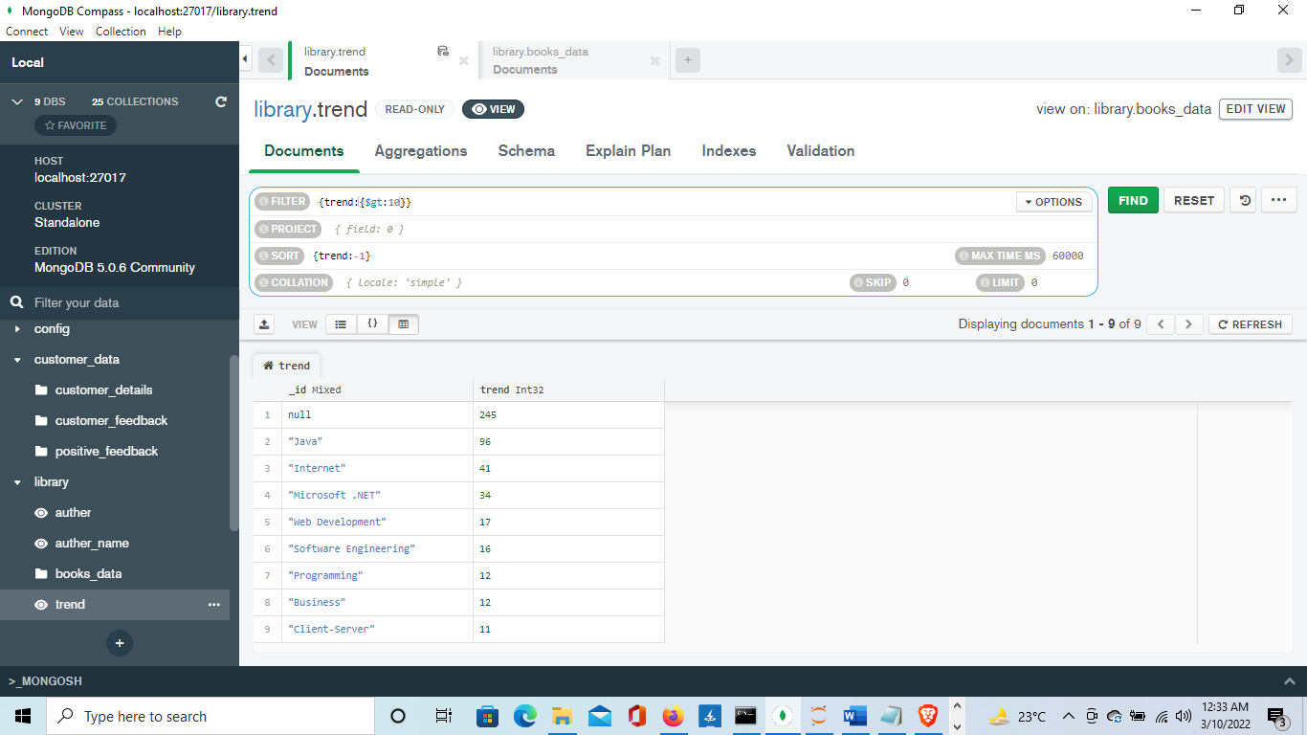

**Task 7**

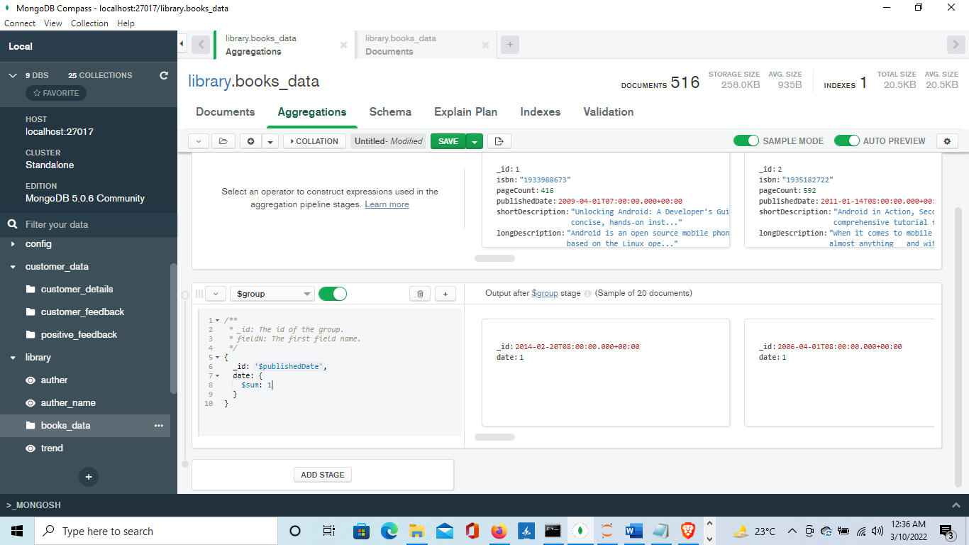

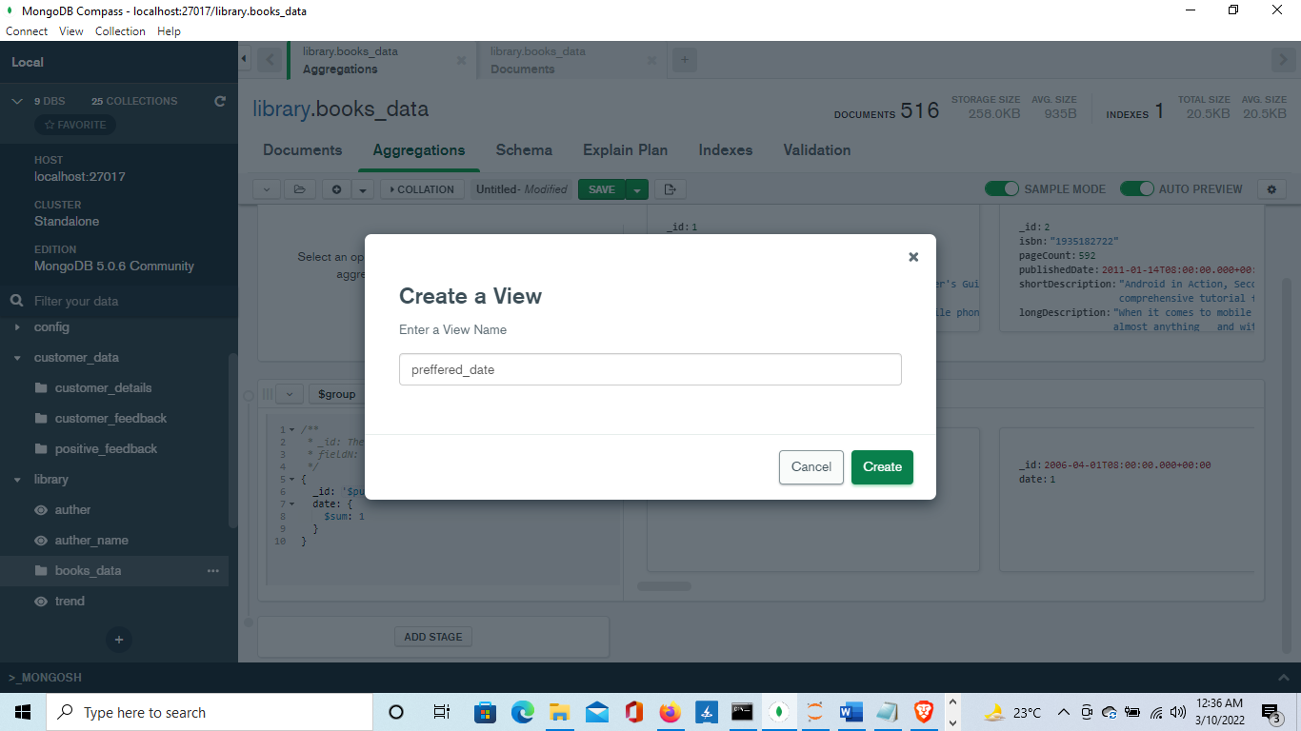

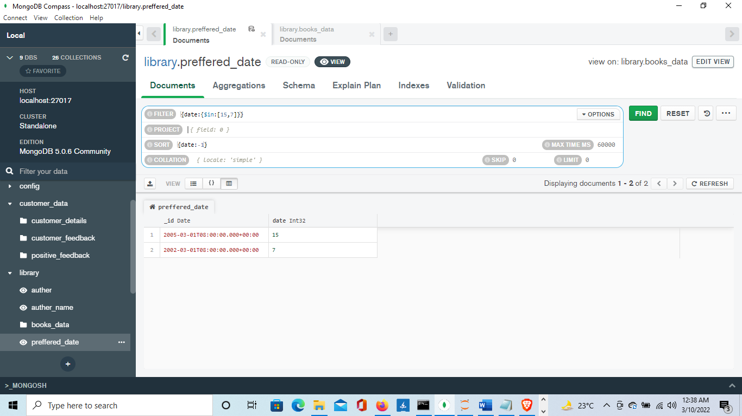

**Task 8**

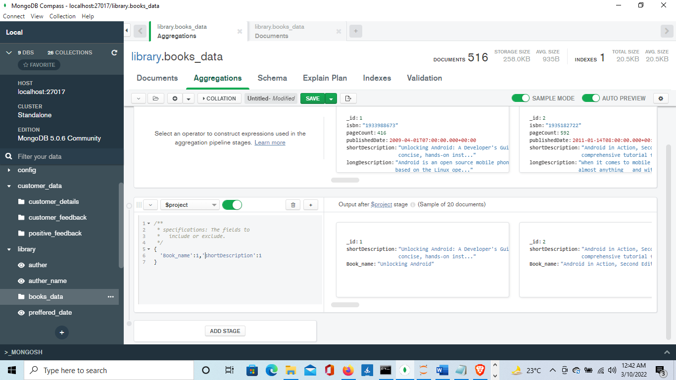

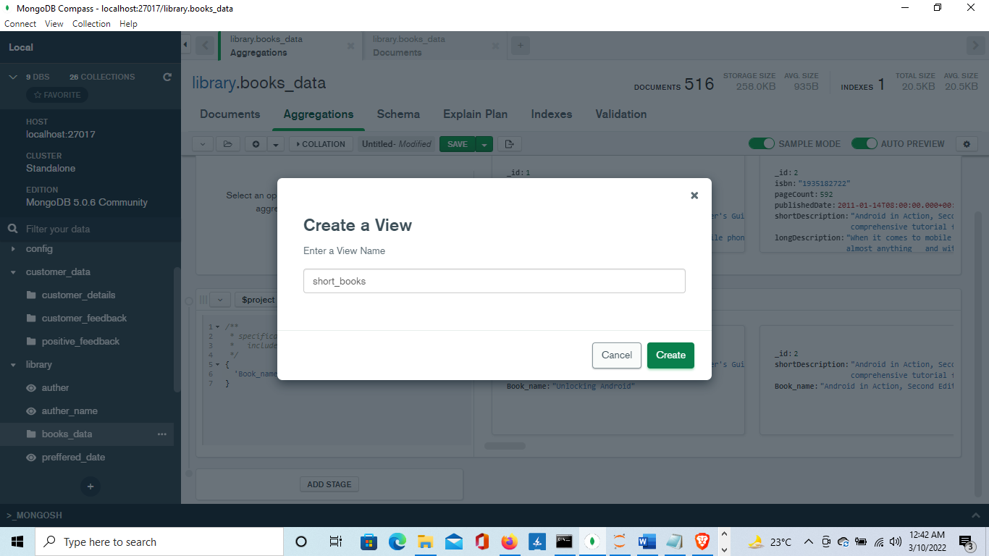

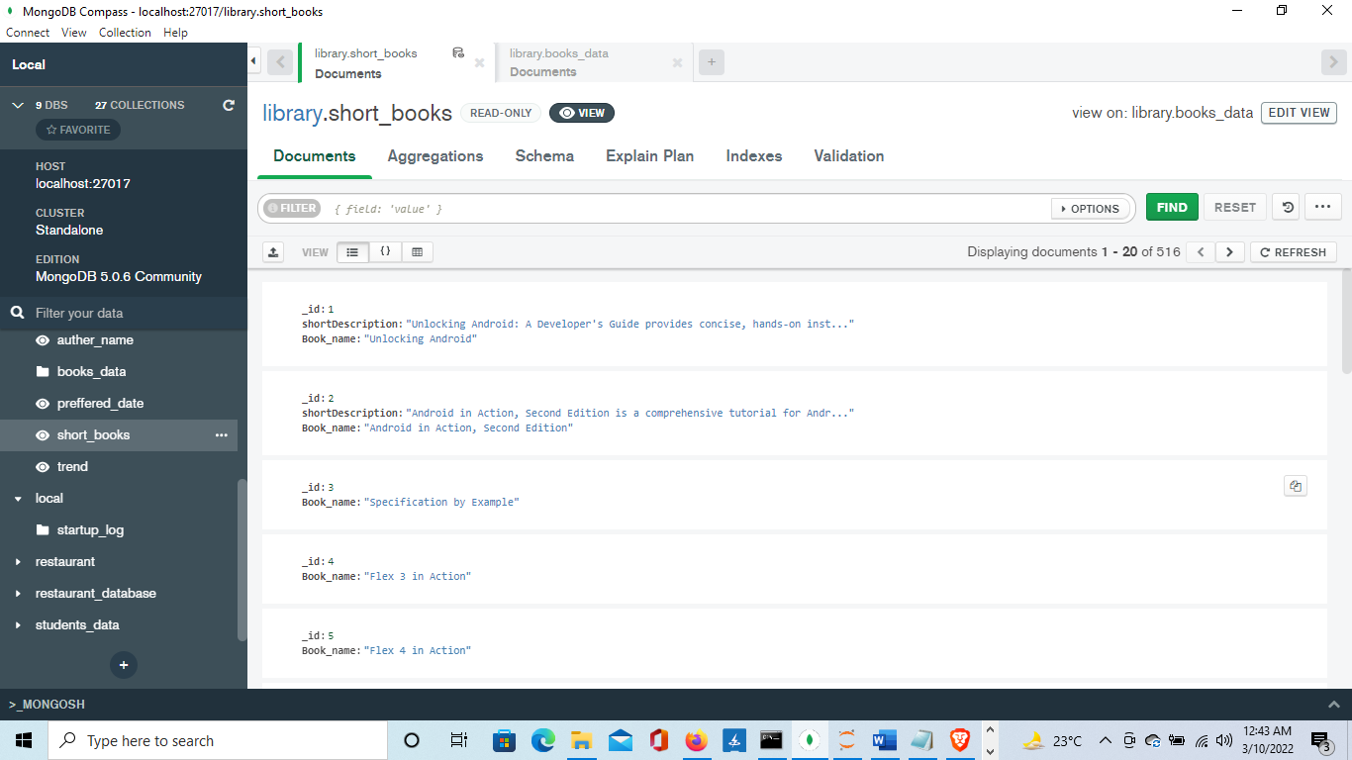

**Task 9**

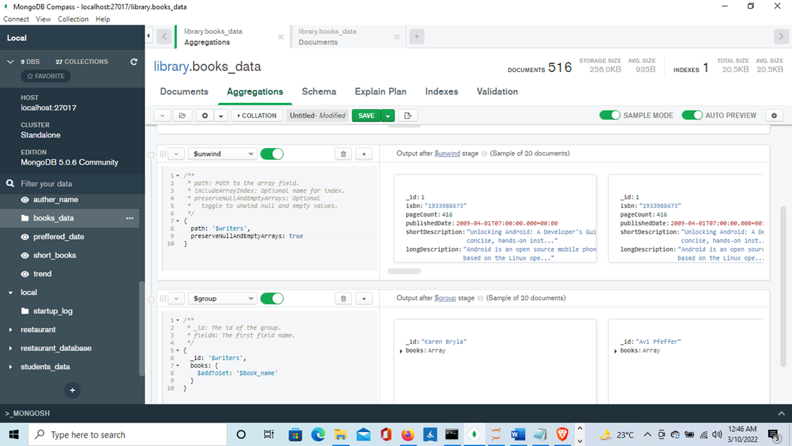

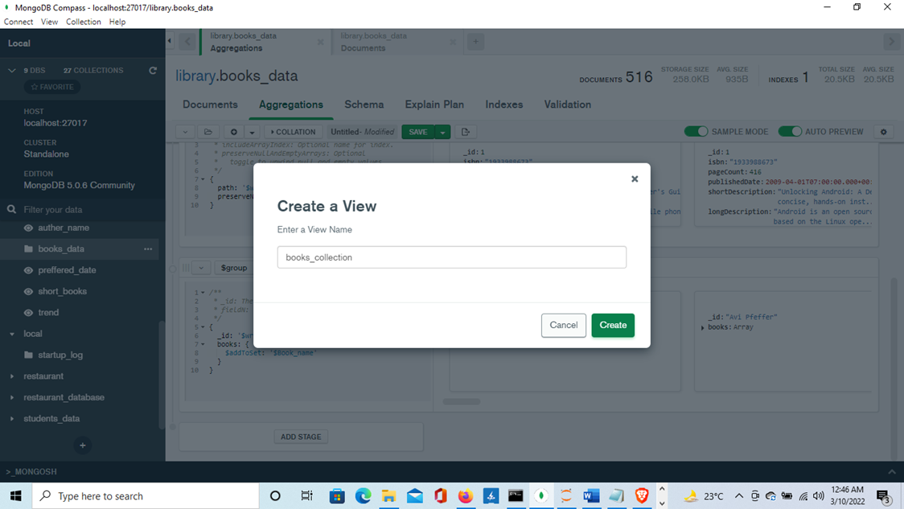

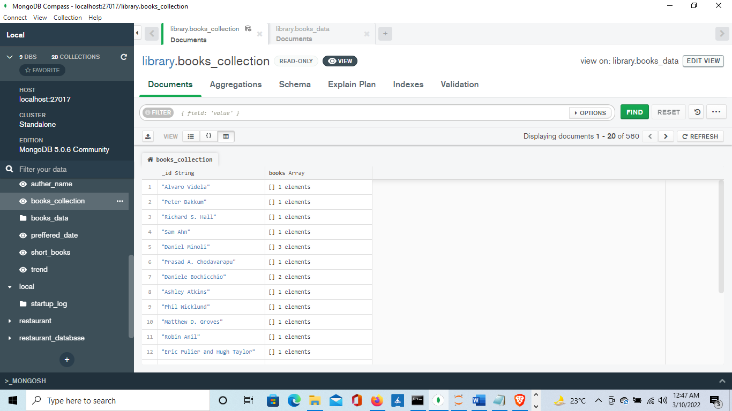

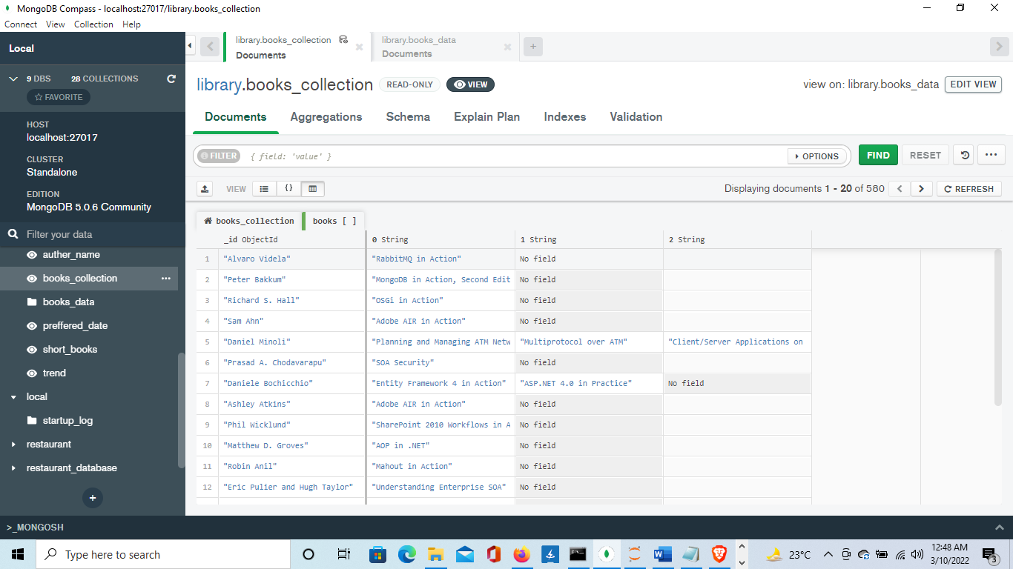

**Task 10**

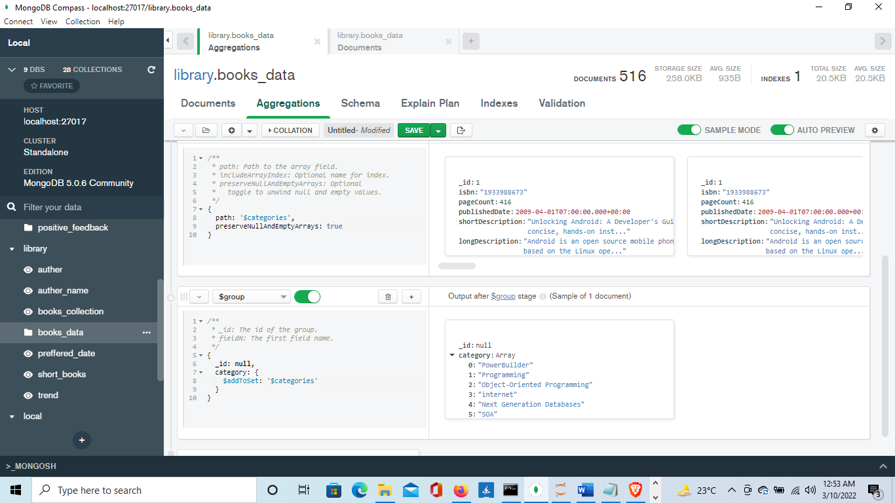

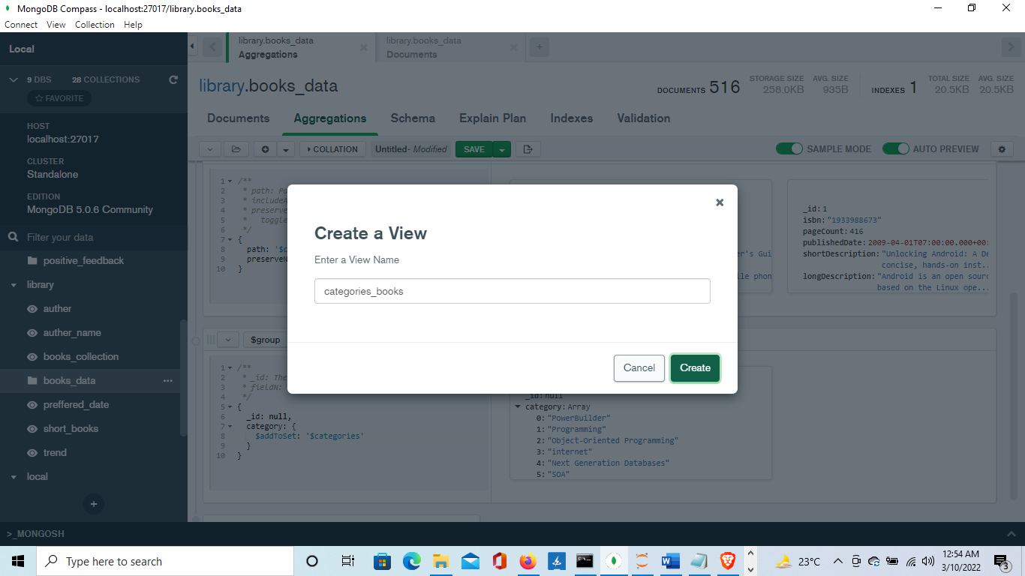

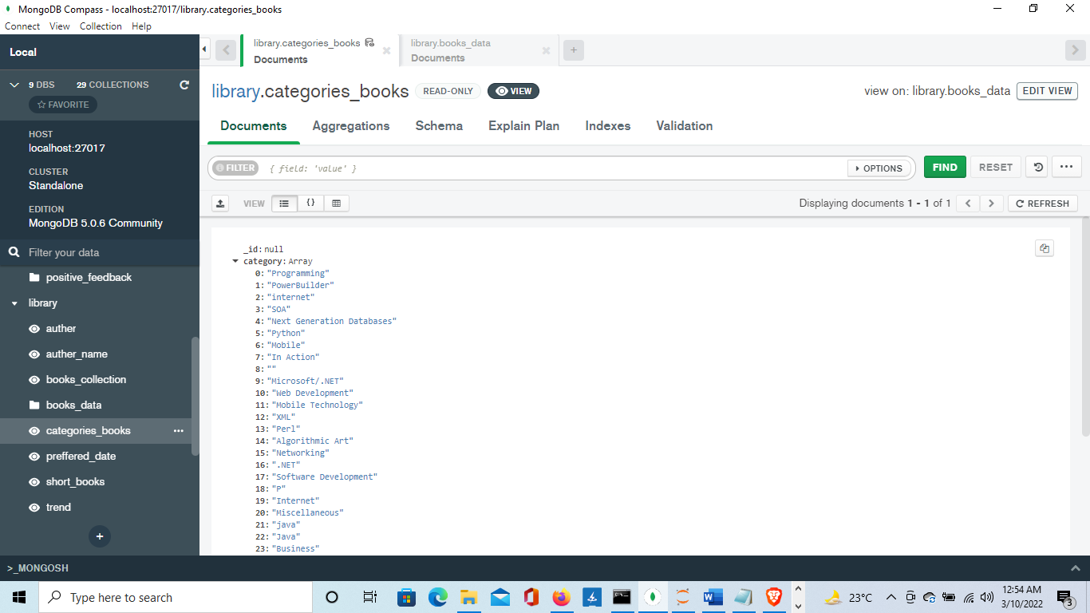

**Task 11**

